Database in Digital Education

Author’s Information

彭菈斐
s24101324@stu.edu.twn
Second Year In Information Management Student

Abstract

In the recent years, the modernization of technology has become an integral part of today’s generation. From early technologies to today’, it has become worldwide and continues to expand at a fast pace, an example of this is the database.
Databases is this type of software that is used to organize and store information in an electronic storage, it features collected data presented in multiple tables with rows and tables. With its purpose and usage specifically in data organization, databases make accessing information easier, allowing users to modify, edit, and retrieve data efficiently. Databases are used in many fields that integrate modern technology, including business, politics, and education.
This article defines what databases are and highlight their use in the field of education. It discusses the definition of educational databases, their relevance to the digital setting of education, and how they are used in schools today.

Introduction

Introduction to Database
History of Databases goes back to the 1960s as it was first developed to help corporations manage complex data. These early database structures were arranged using network and hierarchical frameworks. In the 1970s, Edgar F. Codd introduced the relational model, which changed how data was organized by using tables to represent data. Database systems have continued to evolve and now include technologies that are designed to manage unstructured data.
Databases are defined as collections of organized data that are electronically stored in a computer system. Database Management Systems (DBMS) are used to manage these data by organizing them into rows and columns. Structured Query Language (SQL) is commonly used to create, manage, and retrieve data from databases.
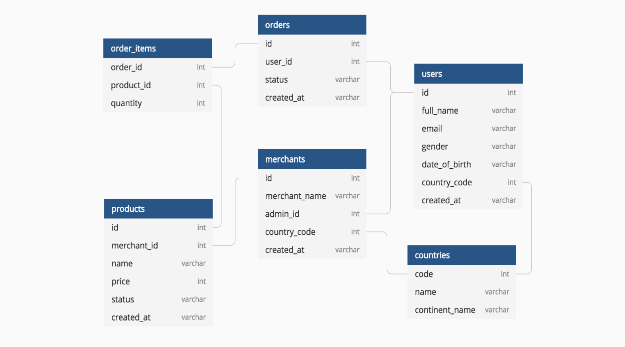

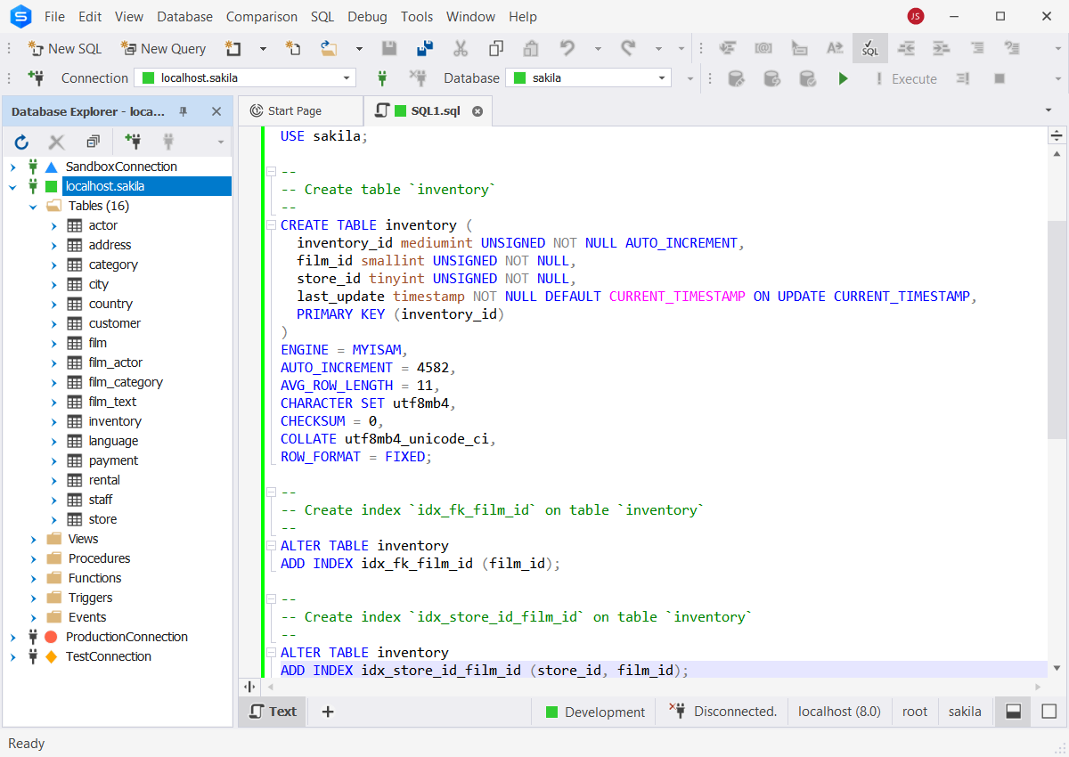
Figure 1. How Database arranges data in a simple graph (DBMS)

Figure 2. How to modify tables of data using SQL (Structure Query Language)

Databases contain organized data files such as personal information (e.g., phone numbers and email addresses) and financial records, including dates and transaction histories. SQL queries allow users to filter and retrieve specific information from a database. These systems are essential for storing large volumes of data as it makes it easy to access, maintain, update, and retrieve it. This simplifies navigation through hundreds or thousands of data points, making data organization more convenient and time-efficient.

As a result, databases are widely used across modern institutions and technologies. Sectors such as social media, education, healthcare, and finance rely on databases not only for data organization but also for efficient information tracking. This paper focuses on the usage and relevance of databases in modern education.

Introduction to Digital Education
The term, Digital Education, is defined as the usage of digital technologies in learning or teaching. From online courses and interactive digital classrooms, it differs from the old tradition of having to attend school face-to-face. With these, students can access information via e-books, online articles in the comfort of their own homes or devices where they can view it everywhere. It goes to same as teachers where they can share content of their courses/lessons to their students without the need for printed copies of lessons. With the rapid growth of technology, this helps educators in integrating themselves in the digital world and gain skills that come from learning.

Database and Digital Education
Education applications are widely used, converting traditional textbooks to digital e-books, courses available to view online through the use of devices (Mobile Phones, Computers). As of now, many schools use Learning Management Systems (LMS) to provide access to course materials such as PowerPoint presentations and PDF documents to students online. Databases operate behind the scenes of these systems to organize and manage large collections of educational resources not limited to information on courses but also personal data on those involved in the education field.

Education Databases

Definition of Education Database
Education databases are collections of data arranged in tables with rows and columns for the purpose of managing, storing, and retrieving educational information. This system is specifically used in school systems.
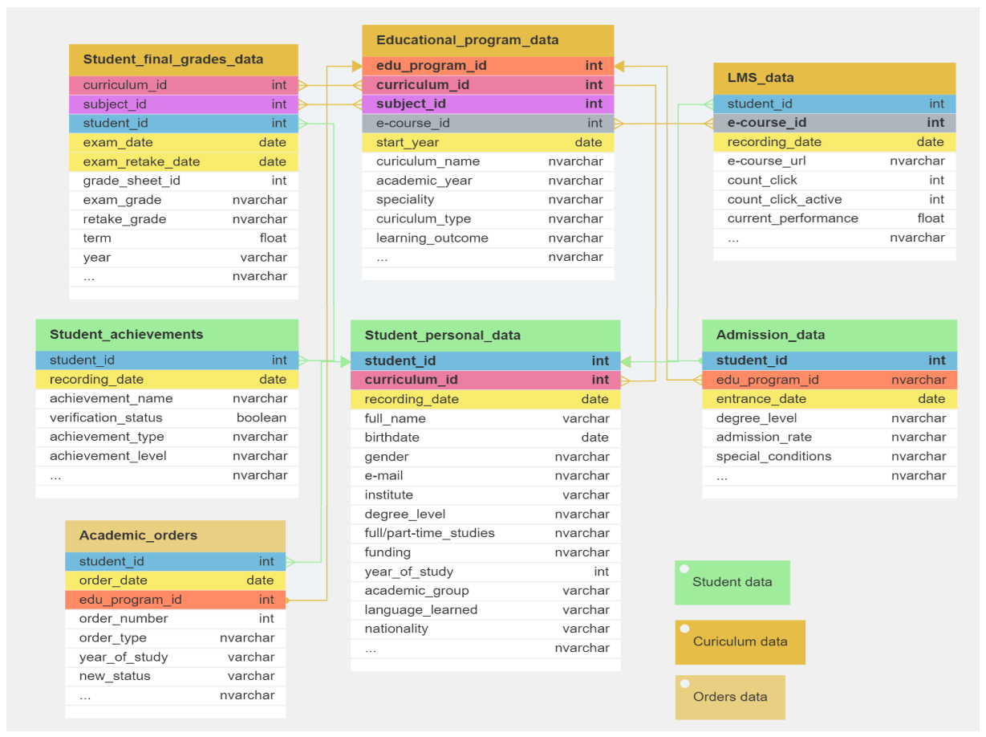
Figure 3. DB EduHistory database schema.

Data stored in these databases are not limited to: academic resources which includes research papers and e-books, as well as demographic data related to students, faculty, and facilities. Education databases are specifically designed to support educational environments, given the rapid development of technology.

Overview on How It’s Used in Digital Education
The use of education databases has made access to educational data more efficient. Teachers and administrators can easily monitor specific types of information, such as student academic progress, enrollment records, and course materials. Beyond monitoring, education databases also provide learners access to research resources used for assignments and academic projects from professors from different courses. Overall, these databases offer practical tools that enhance student learning experiences while enabling faculty and administrators for easy manage on large volumes of data effectively.

Practical Usage and Examples

Types of Education Databases

Learning Management Systems (LMS)
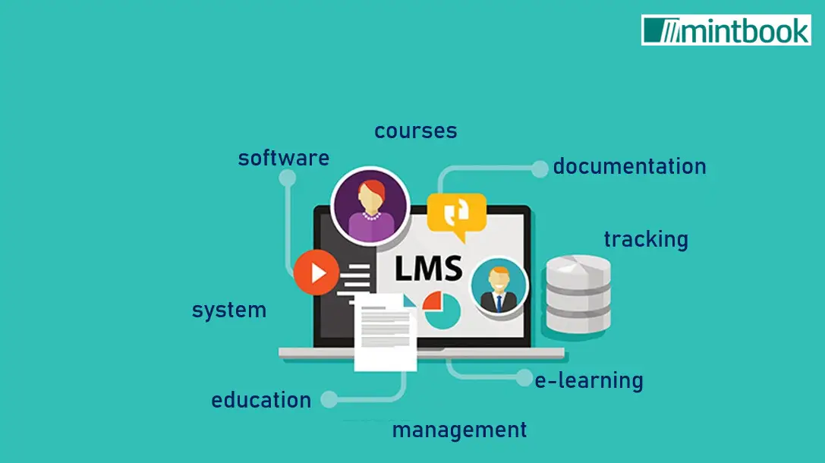
Learning Management Systems are widely used by schools to deliver lessons and manage academic activities. These platforms provide access to digital textbooks, lecture materials in the form of PowerPoint presentations, assignments, and examinations. TronClass, which is used in some courses, allows students to view their enrolled classes for the semester. Professors can upload materials, publish assignments, and conduct class activities within the system. Another commonly used LMS with similar functionality is Moodle.
Figure 4. Learning Management System (LMS)

Student Information System (SIS)
Another software application used by schools for easy management and store data from students. These data include attendance lists, individual grades, class and other schedules, information on each student, enrollments, and many more.

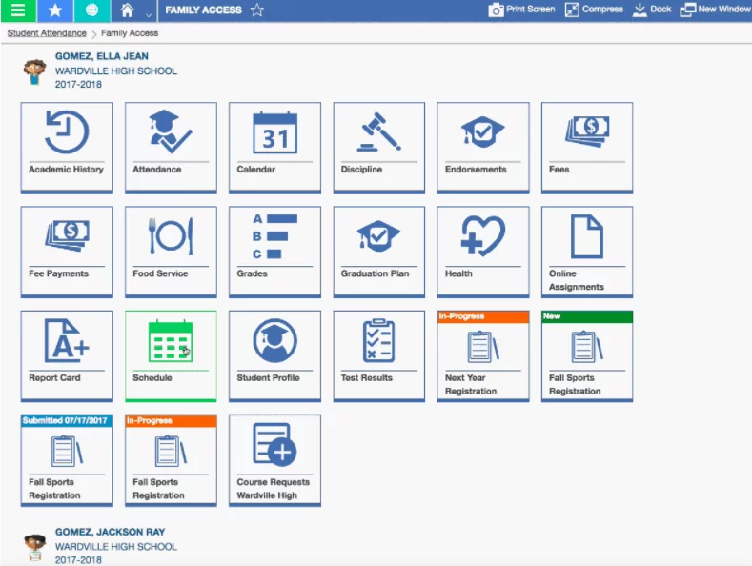
With this application, it can be accessed and modified by academic users like students and professors. This ultimately makes things more convenient to view numbers of data compared to using paper and pen.

Figure 5. Skyward and Their Student Information System (Family Access)

Conclusion
Narrowing down to what has been discussed, database is a software application shown to have been used in different sectors in today’s society, especially in education. With how fast the development of technology now, will the functionality of database also improve, becoming an integral to modern technologies present in our daily lives.
We continue to see more schools utilize digital usage in their approach for learning educators and with the help these databases, organizing information has been made easier.

References
- devart. Top-rated all-in-one MySQL IDE. devart. https://www.devart.com/dbforge/mysql/studio/mysql-code-editor.html
- Do, A.. (2025). Top 10 Free Database Diagram Design Tools. holistics. https://www.holistics.io/blog/top-5-free-database-diagram-design-tools/
- Erin, R. est. (2023). Designing an Education Database in a Higher Education Institution for the Data-Driven Management of the Educational Process. Research Data.https://www.researchgate.net/publication/373981669_Designing_an_Education_Database_in_a_Higher_Education_Institution_for_the_Data-Driven_Management_of_the_Educational_Process
- HEMS5. (2021). 10 Things You Should Look for in a Student Information System. Higher Education Marketing. https://www.higher-education-marketing.com/blog/10-things-you-should-look-for-in-a-student-information-system
- Mintbook. (2024). What is a Learning Management System (LMS)?. mintbook. https://mintbook.com/blog/what-is-a-learning-management-system-lms/
- tadabase. (2024). Understanding Education Databases. tadabase. https://tadabase.io/blog/understanding-education-databases

